Chap 14. INVENTORY MODELS

Economic Order Quantity (EOQ model)
Glossary p659
Assumptions (table 14.3 p633)
Template Fig 14.4 p632

Inventory pattern

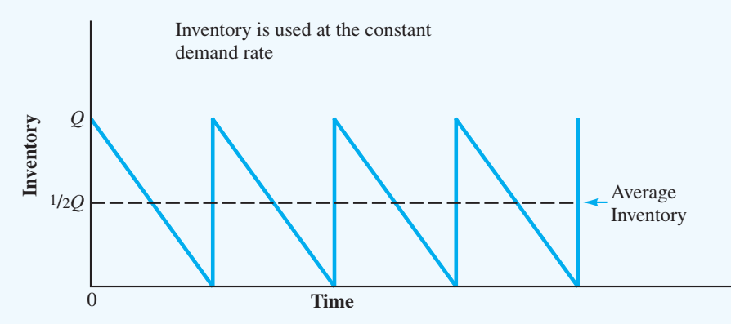

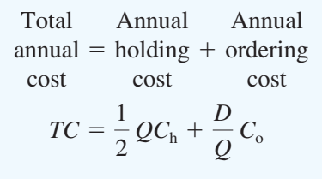

E3d p661 (long lead-time)
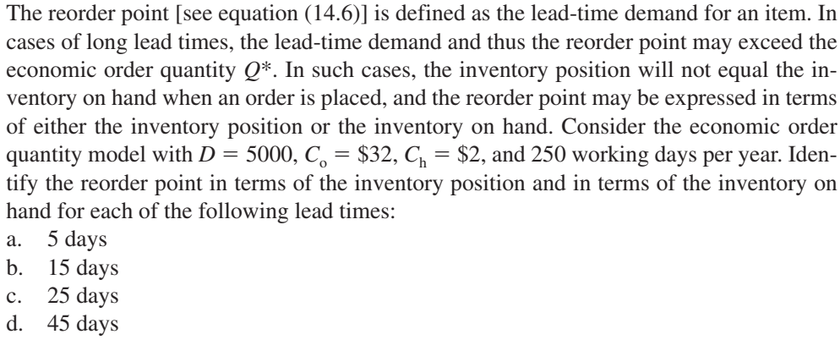

a. r = dm = 20(5) = 100

Since r  Q*, both inventory position and inventory on hand equal 100.

b. r = dm = 20(15) = 300

Since r  Q*, both inventory position and inventory on hand equal 300.

c. r = dm = 20(25) = 500

Inventory position reorder point = 500. One order of Q* = 400 is outstanding. The on-hand inventory reorder point is 500 - 400 = 100.

d. r = dm = 20(45) = 900

Inventory position reorder point = 900. Two orders of Q* = 400 are outstanding. The on-hand inventory reorder point is 900 - 2(400) = 100.

E6b) p 661 (shipment consolidation)

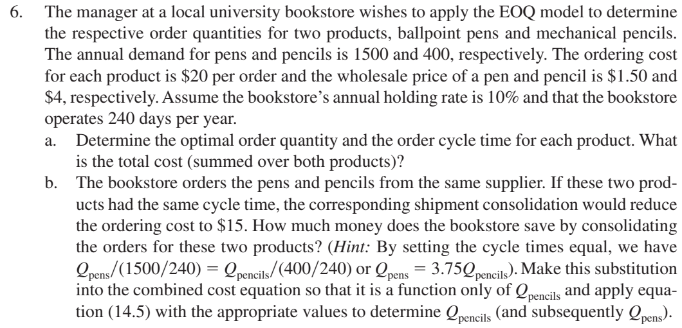

a. = 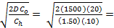632 pens,
= 101 days

= 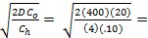200 pencils,
= 120 days
Thus, the total cost is $94.87 + $80 = $174.87.

- Setting the cycle times of pens and pencils equal:

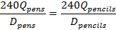 which implies .

The total cost (for both pens and pencils) is:

Substituting , we obtain

Combining like terms:

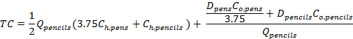

Solving for by observing that this total cost equation is the same as
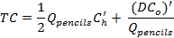
where and .

Thus,
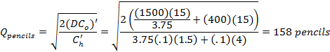

These quantities are ordered every T = (240)(593)/1500 = (240)(158)/400 = 95 days. The total cost (for both pens and pencils) is:

Thus, the consolidate shipments result in annual savings of $174.87 - $151.99 = $22.88.

E8 p 661 (Bus driver-training program)

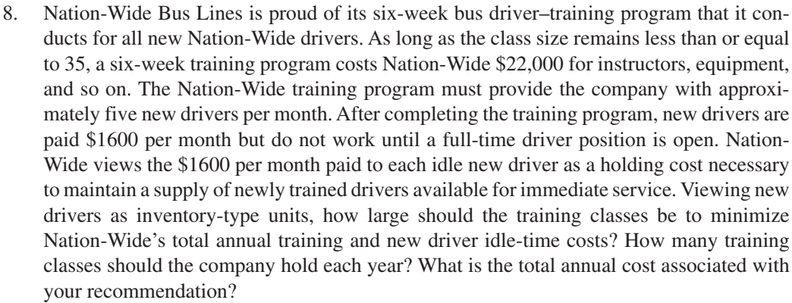

Annual Demand D = (5/month)(12 months) = 60

Ordering Cost = Fixed Cost per class = $22,000

Holding Cost = ($1,600/month)(12 months) = $19,200 per year for one driver

Rounding up to get 12 as the class size.

D/Q* = 60/12 = 5 classes per year

Driver holding cost =

Class holding cost =

Total cost = $225,200

Economic Production Lot Size (EPLS) model

- Inventory pattern for the production lot size
- ﻿Production phase: inventory build up during the production period
- ﻿Nonproduction phase: the continuing demand causes the inventory to gradually decline.

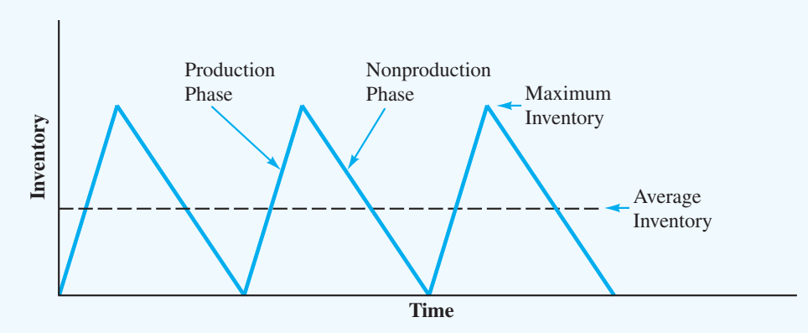

Given inputs: holding cost (Ch), setup cost per run (Co),
annual demand rate (D) < annual production rate (P)

﻿Economic Production Lot Size
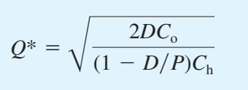

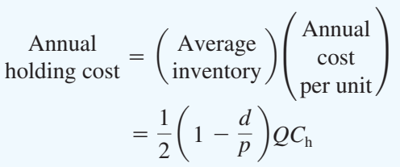, 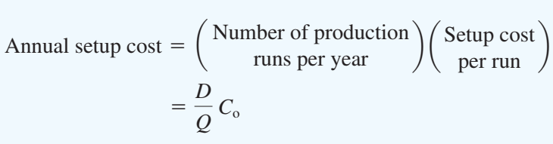

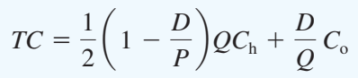

Mock Test E4
A well-known publishing company produces books for the retail market. Demand for a current book is expected to occur at a constant annual rate of 8520 copies. The cost of a copy of the book is $16, and the annual holding cost is based on a 20% rate. Production setup costs are $120 per run. The production line on which the book is produced has an annual production capacity of 16000 copies. Current practice calls for production runs of 710 copies per month.
- Rewrite the inputs using standard notations (D, P, …)
- What is the optimal production lot size? What is the cycle time assuming 250 working days per year? (round to the nearest integer)
- How much is the company losing annually with their current production schedule, comparing with the optimal production lot size? (round to one decimal place)

E12 p662 (EL Computer)
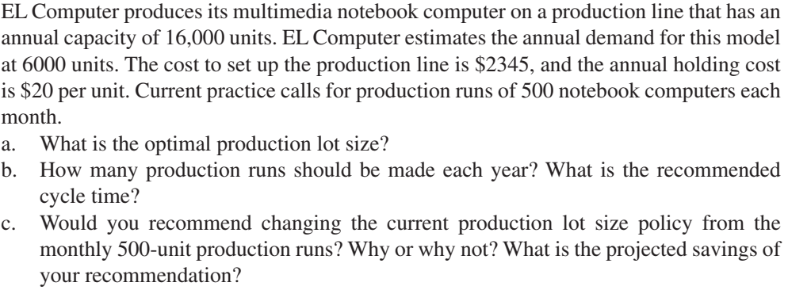

E 13 p662 (Wilson Publishing Company)

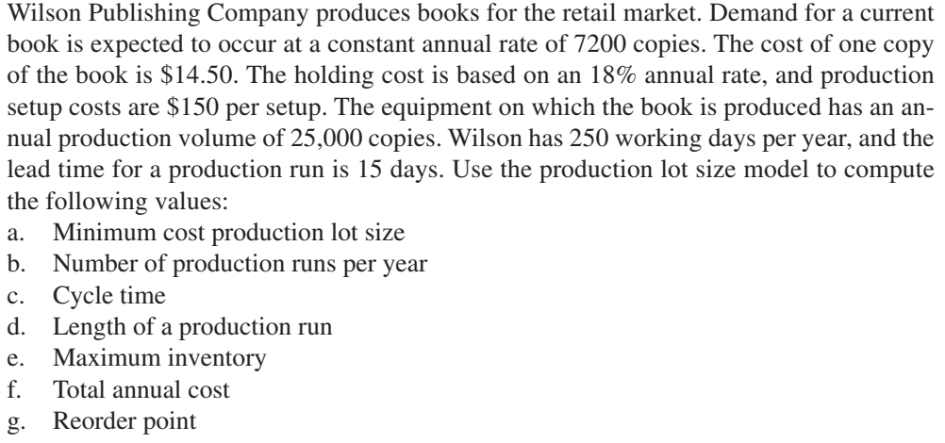

PERT/ CPM

15. a.

b.
Activity |  | Expected Time |  |  | Variance
A |  | 2 |  |  | 0.03
B |  | 3 |  |  | 0.44
C |  | 2 |  |  | 0.11
D |  | 2 |  |  | 0.03
E |  | 1 |  |  | 0.03
F |  | 2 |  |  | 0.11
G |  | 4 |  |  | 0.44
H |  | 4 |  |  | 0.11
I |  | 2 |  |  | 0.03
Activity | Earliest  Start |  | Latest  Start | Earliest  Finish |  | Latest  Finish | Slack |  | Critical  Activity
A | 0 |  | 0 | 2 |  | 2 | 0 |  | Yes
B | 2 |  | 2 | 5 |  | 5 | 0 |  | Yes
C | 0 |  | 1 | 2 |  | 3 | 1
D | 2 |  | 3 | 4 |  | 5 | 1
E | 5 |  | 10 | 6 |  | 11 | 5
F | 6 |  | 11 | 8 |  | 13 | 5
G | 5 |  | 5 | 9 |  | 9 | 0 |  | Yes
H | 9 |  | 9 | 13 |  | 13 | 0 |  | Yes
I | 13 |  | 13 | 15 |  | 15 | 0 |  | Yes

c. Critical Path: A-B-G-H-I

E(T) = 2 + 3 + 4 + 4 + 2 = 15 weeks

d. Variance on critical path

σ2 = 0.03 + 0.44 + 0.44 + 0.11 + 0.03 = 1.05

From the table for standard normal distribution, the cumulative probability of 0.99
occurs at z = 2.33. Thus

